Kanan Ibadzade

Efe Gur Bahadir, Jarred Chen, Zhi Hao Chong

Newton’s 2nd Law Lab

OBJECTIVE

1. Calculate the theoretical acceleration atheo of the system by applying Newton’s 2nd Law.
2. Calculate the experimental acceleration aexp of the system by two different methods using the kinematic equations of motion.
3. Compare aexp with atheo.

APPARATUS

1. Air track, blower with hose, and power cord

2. Two photogates

3. Glider

4. Accessory box

5. String

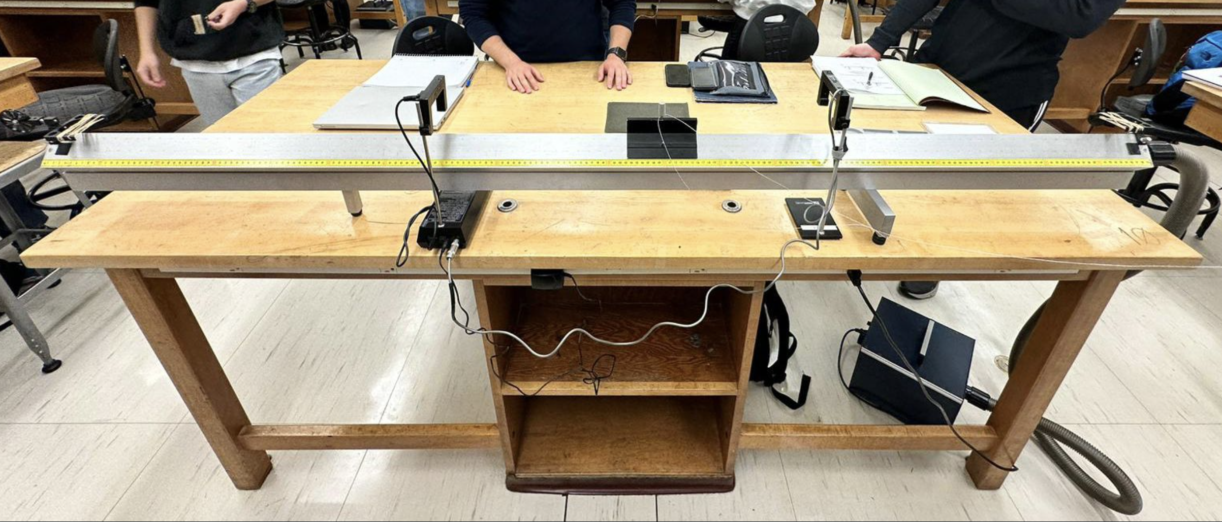

THEORY

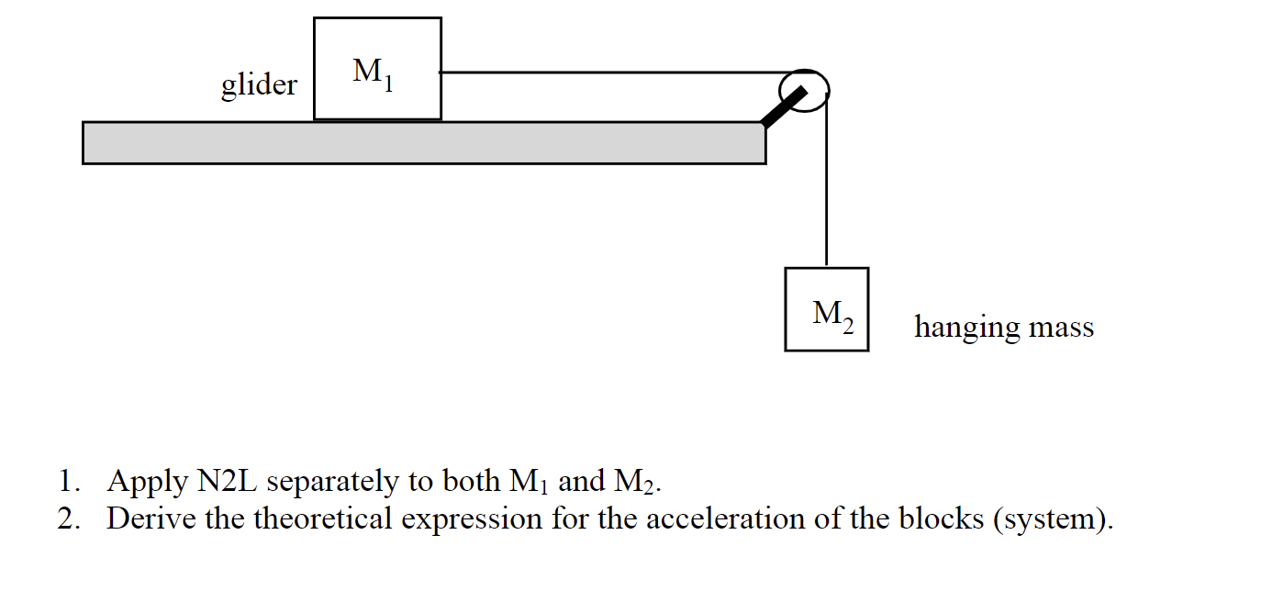

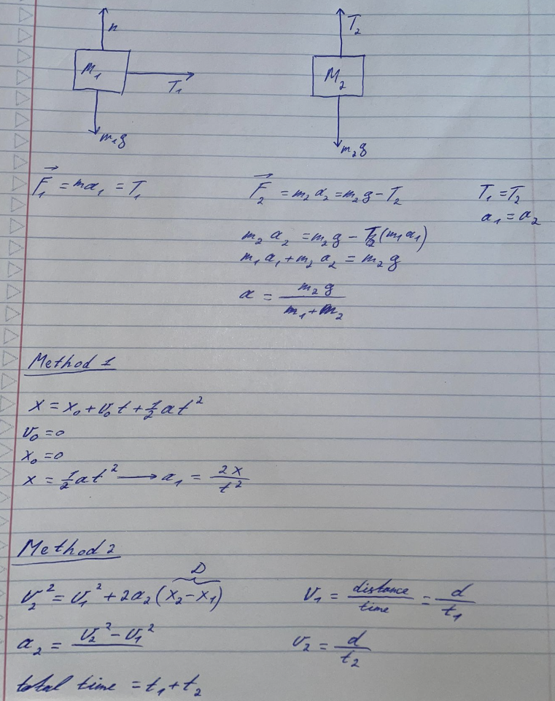

PROCEDURE

# Method 1

1. Level air track.
2. Set the distance between the photogates approximately x ≈ 70 cm.
3. Set M1 ≈ 200 g and M2 ≈ 35 g. M1 will just be equal to the mass of the glider.
4. Set photogates on PULSE MODE.
5. Release M1 from rest at photogate 1.
6. Measure time for M1 to reach photogate 2.
7. Repeat steps (4) and (5) for a total of 5 runs.
8. Calculate aexp for each run and find aave.

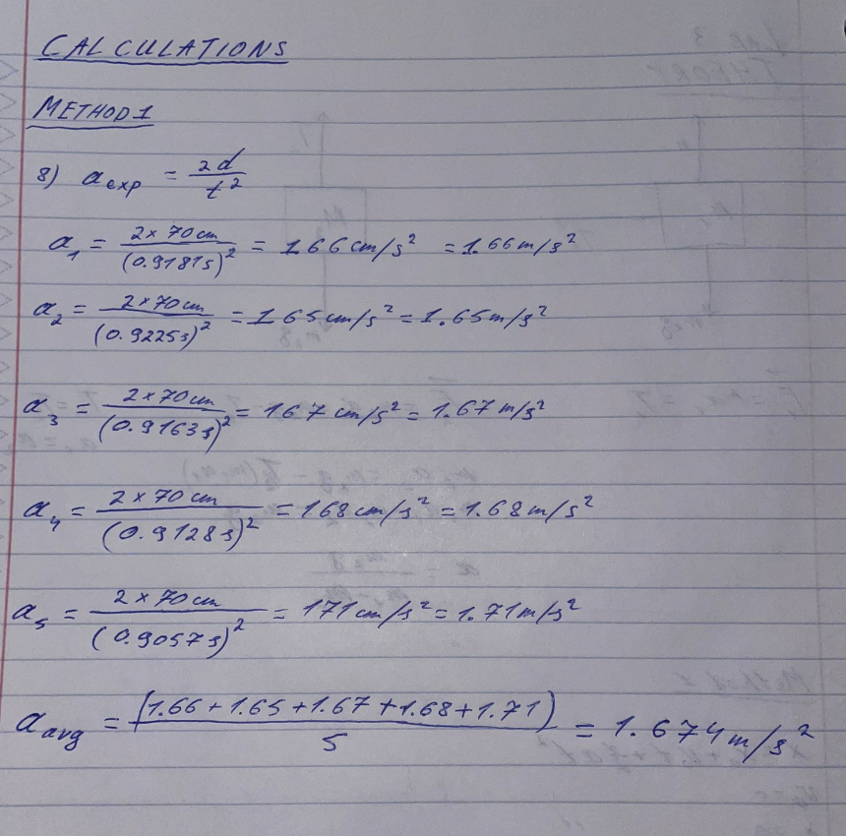

# Method 2

1. Attach the small flag from the accessory box onto M1.
2. Use x ≈ 70 cm and same M2 as Method 1. Measure M1.
3. Measure the length of flag on M1 using the Vernier calipers.
4. Set the photogates on GATE MODE and MEMORY ON.
5. Release M1 from rest at 20 cm away from photogate 1.
6. Measure time t1 through photogate 1 and time t2 through photogate 2.
7. Calculate V1 and V2. These are the speeds of the glider (M1) as it passes through photogate 1 and photogate 2 respectively.
8. Repeat steps (5) – (7) for a total of 5 runs.
9. Calculate aexp for each run and find aave.

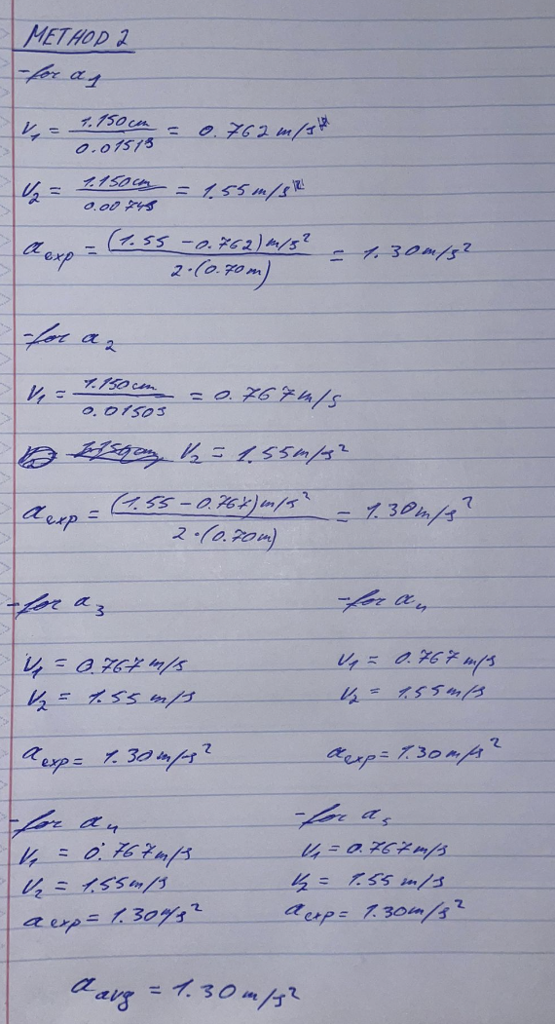

DATA

# Method 1

|  |  |
| --- | --- |
| Hanging Mass | Mass (g) |
| M1 | 198.21 ±0.01 |
| M2 | 40.00±0.01 |

|  |  |  |
| --- | --- | --- |
| Runs | t (s) | aexp (m/s2) |
| 1 | 0.9181 | 1.66 |
| 2 | 0.9225 | 1.65 |
| 3 | 0.9163 | 1.67 |
| 4 | 0.9128 | 1.68 |
| 5 | 0.9057 | 1.71 |

# Method 2

# 

|  |  |
| --- | --- |
| Hanging Mass | Mass (g) |
| M1 | 199.00±0.01 |
| M2 | 35.12±0.01 |

|  |  |  |
| --- | --- | --- |
| Runs | t1 (s) | v1 (m/s) |
| 1 | 0.0151 | 0.762 |
| 2 | 0.0150 | 0.767 |
| 3 | 0.0150 | 0.767 |
| 4 | 0.0150 | 0.767 |
| 5 | 0.0150 | 0.767 |

|  |  |  |
| --- | --- | --- |
| Runs | t2(s) | v2 (m/s) |
| 1 | 0.0074 | 1.55 |
| 2 | 0.0074 | 1.55 |
| 3 | 0.0074 | 1.55 |
| 4 | 0.0074 | 1.55 |
| 5 | 0.0074 | 1.55 |

|  |  |
| --- | --- |
| Runs | aexp (m/s2) |
| 1 | 1.30 |
| 2 | 1.30 |
| 3 | 1.30 |
| 4 | 1.30 |
| 5 | 1.30 |

CALCULATIONS





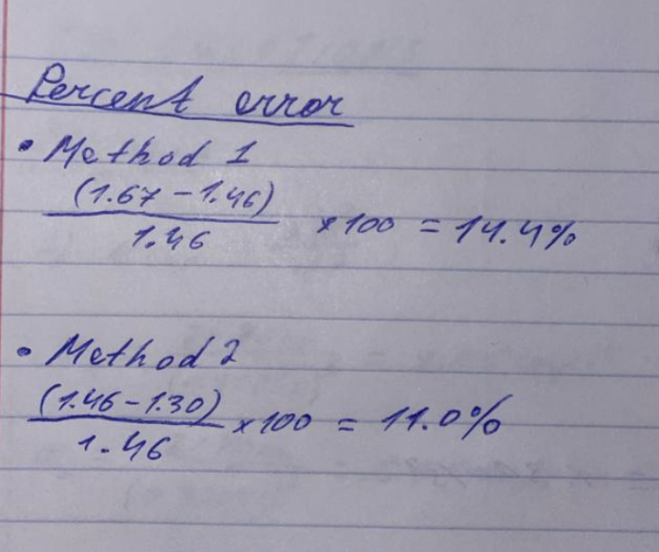

CONCLUSION & RESULTS

Using the masses M1 and M2, we used Newton's Second Law to calculate a theoretical acceleration. When compared to the outcomes of our experiments, Method 1 produced a greater inaccuracy, but Method 2 produced findings that were more in line with the predicted acceleration of 1.46 m/s². Our objective was to measure experimental acceleration using kinematics, compute theoretical acceleration based on theory, and compare the results to determine the percentage inaccuracy. With the assistance of our lab partners and professor, this was accomplished. We were able to compute experimental acceleration using mass and time data, as well as theoretical acceleration derived from Newton's 2nd Law. A systematic mistake might be caused by a little misalignment of the horizontal air track. It resulted in a deviation of the measured acceleration from the predicted value, which raised the error percentage. A random mistake was made by the airflow from the air track. This might support or obstruct the motion, changing the experimental acceleration from the expected 1.46 m/s² to a value that is greater or lower. In conclusion, even though we achieved the lab's goals, systematic and random mistakes affected our findings and caused them to deviate from the predicted values.